Mannering Park Historic Trail
Developed by Mannering Park Progress 2024
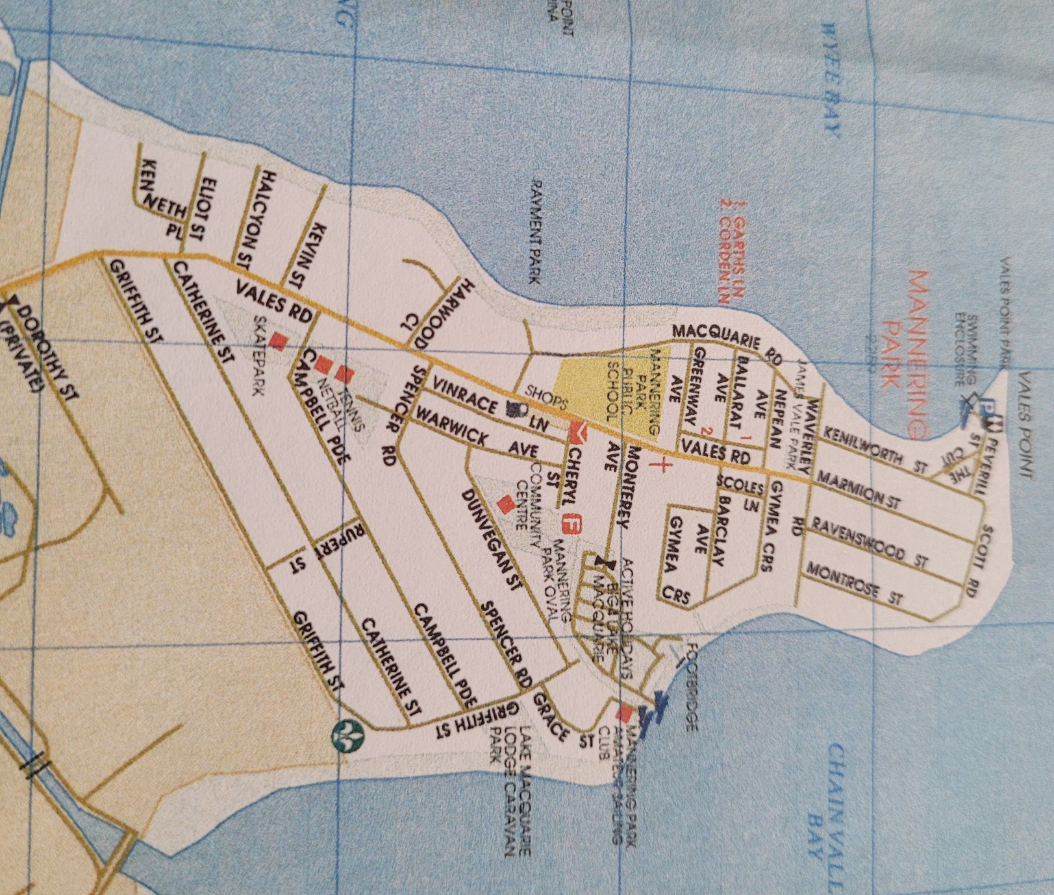
4. Garth’s Point sign, bottom The Cut and Peverill Streets
5. James Vinrace Vale’s sign, corner Vales and Waverley Roads
6. Country Women’s Association Hall sign, Warwick Avenue
7.Community Hall sign, Dunvegan Street
8.Coral Burnham’s Memorial Bench Seat Shared Pathway

LEGEND
1.Delta sign, beginning Shared Pathway, Griffith Street
2. Monterey Auto Camp sign, bridge Holiday Park, shared pathway
3. Co-operative and Fishing Industry, bottom Waverley Road

8
1

3
4
5
6
7
2

